**Assignment - 5 A Job Ready Bootcamp in C++, DSA and IOT**

More on Iterative Control Statements

**1. Write a program to print MySirG N times on the screen**

#include<stdio.h>

int main()

{

int n,i=1;

printf("Enter how many times you print ");

scanf("%d",&n);

while(i<=n)

{

printf("MySirG\n");

i++;

}

return 0;

}

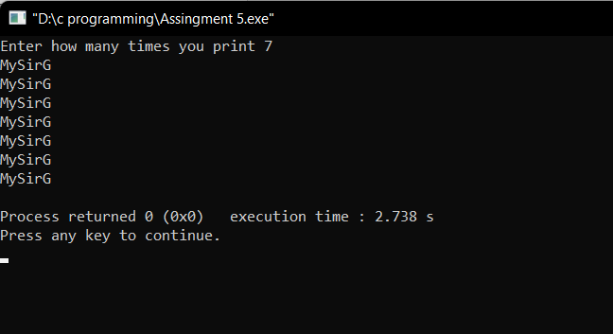

**2. Write a program to print the first N natural numbers.**

#include<stdio.h>

int main()

{

int n,i=1;

printf("Enter how many natural number you want to print ");

scanf("%d",&n);

while(i<=n)

{

printf("%d\n",i);

i++;

}

return 0;

}

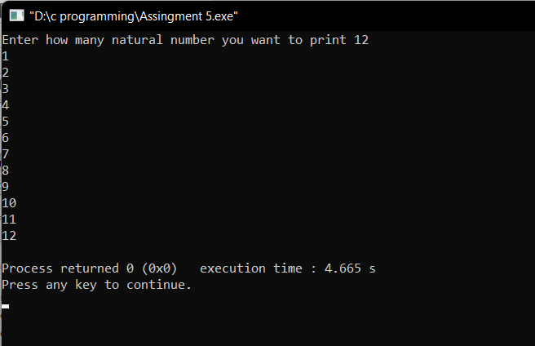

**3. Write a program to print the first N natural numbers in reverse order**

#include<stdio.h>

int main()

{

int n;

printf("Enter how many natural number in reverse you want to print ");

scanf("%d",&n);

while(n>=1)

{

printf("%d\n",n);

n--;

}

return 0;

}

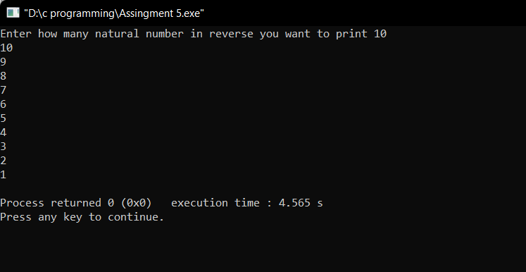

**4. Write a program to print the first N odd natural numbers**

#include<stdio.h>

int main()

{

int n,i=1;

printf("Enter how many odd natural numbers you want to print ");

scanf("%d",&n);

while(i<=n)

{

printf("%d\n",i*2-1);

i++;

}

return 0;

}

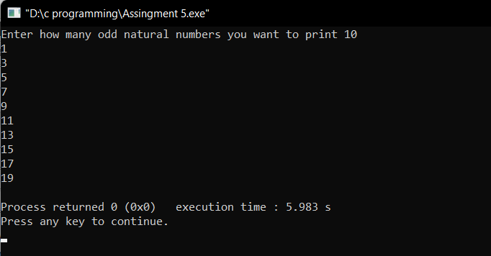

**5. Write a program to print the first N odd natural numbers in reverse order.**

#include<stdio.h>

int main()

{

int n;

printf("Enter how many odd natural numbers in reverse you want to print ");

scanf("%d",&n);

while(n>=1)

{

printf("%d\n",n*2-1);

n--;

}

return 0;

}

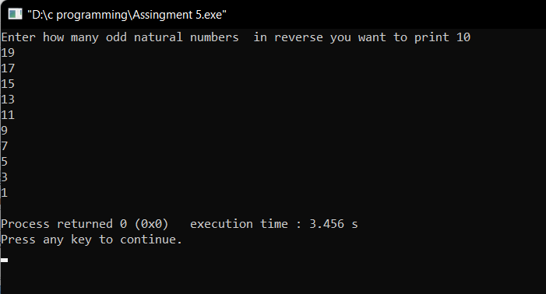

**6. Write a program to print the first N even natural numbers**

#include<stdio.h>

int main()

{

int n,i=1;

printf("Enter how many even natural number you want to print ");

scanf("%d",&n);

while(i<=n)

{

printf("%d\n",i*2);

i++;

}

return 0;

}

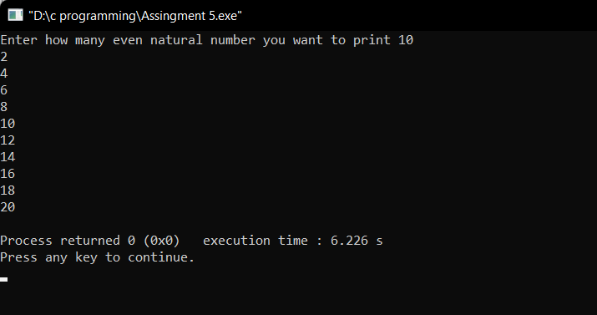

**7. Write a program to print the first N even natural numbers in reverse order**

#include<stdio.h>

int main()

{

int n;

printf("Enter how many even natural number you want to print in reverse order ");

scanf("%d",&n);

while(n>=1)

{

printf("%d\n",n*2);

n--;

}

return 0;

}

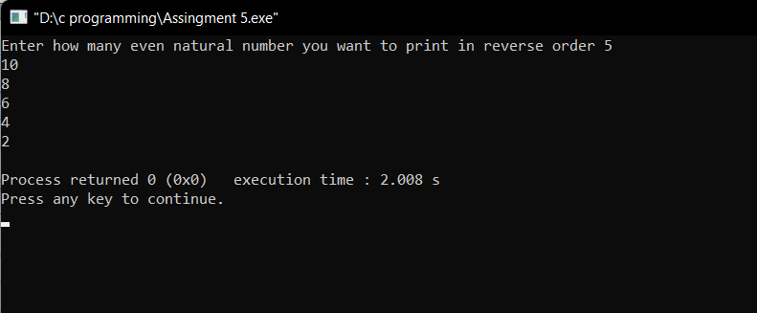

**8. Write a program to print squares of the first N natural numbers**

#include<stdio.h>

int main()

{

int n,i=1;

printf("Enter natural number to print their squares ");

scanf("%d",&n);

while(i<=n)

{

printf("%d\n",i*i);

i++;

}

return 0;

}

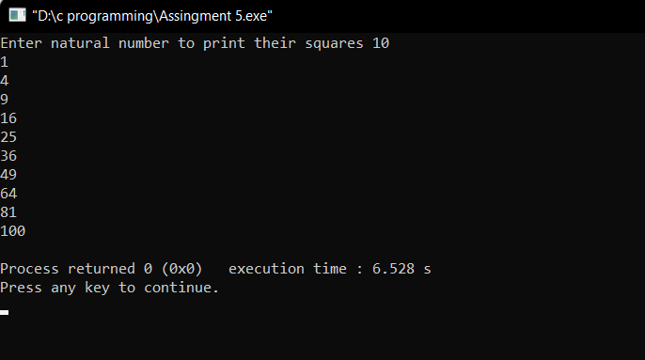

**9. Write a program to print cubes of the first N natural numbers**

#include<stdio.h>

int main()

{

int n,i=1;

printf("Enter natural number to print their cubes ");

scanf("%d",&n);

while(i<=n)

{

printf("%d\n",i*i*i);

i++;

}

return 0;

}

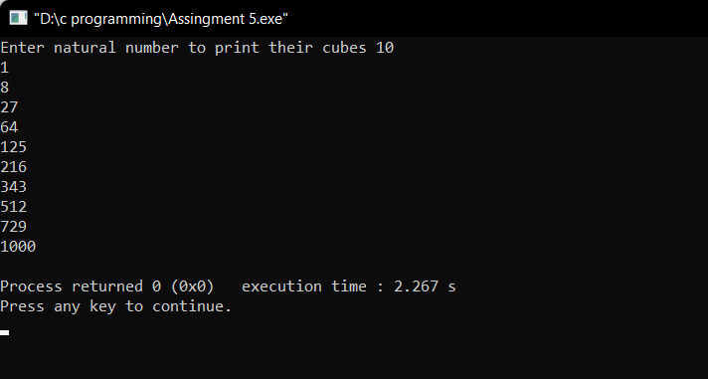

**10. Write a program to print a table of N.**

#include<stdio.h>

int main()

{

int n,i=1;

printf("Enter natural number to print their Table ");

scanf("%d",&n);

while(i!=11)

{

printf("%d * %d = %d\n",n,i,n*i);

i++;

}

return 0;

}

